SwitchVI Experiment 14 July 2005

SwitchVI = Switch Verbal or Implicit structure. Experiment in which color (third dimension) indicates assignment of category labels to the two areas of category structure.

Goal: Find out how number of categories (2 or 4) influence difficulty of the task when the underlying category structure is either rule-based (CJ) or implicit (II).

Motivation: In RBII, we found almost no learning in RBII2 when one of the structures to be learned was II, although the same task was learned in RBII4 . Now we want to look at II II and see, if 2 category task is difficult to learn when using different systems (then II II 2 should not be too bad), or when II is anyhow involved (then II II 2 will be bad, while II II 4 should be ok).

Category structure: Circular category structure including two dimensions. The circular structure consist of 56 stimuli total (28 for each category) organized in three layers. The first layer is a octagon, second 16-gon, and third 32-gon. The circular category structure was obtained by creating three concentric polygons within -1 to 1 scale.
Third dimension (binary) decides which category assignment the stimulus follows. There are 2*56=112 unique stimuli (see figure).

Stimuli: Ellipses that vary in major axis and orientation (dimensions determining category structure) and color (black or white determining category assignment).
The major axis is given by x-value and orientation of the main axis by y-value. Minor axis was kept constant. Color of the elipse was given by third dimension. Value of zero is interpreted as black elipse while value of one as white elipse.
Minor axis was chosen to be 40 pixels.
Major axis varied between 1.5 and 2.5 times minor axis.
Orientation varied between pi/16 and 7pi/16.

Example of a stimulus.


Experiment design:
There will be 2 (number of categories: 2 or 4) x 2 (category structure: II or CJ) experimental design. Conditions for this experiment (inputed with subject data):
1 II II 2 3 II II 4
2 CJ CJ 2 4 CJ CJ 4
There are 4 blocks of 112 stimuli, making 448 trials. During break, message “You have completed X out of 448 trials. Nice job. Press any key to continue.” appears.

Response keys are “C” “V” “B” and “N” in 4 cat condition and “Z” and “M” in 2 cat.
Bonus will be given for 70% accuracy in the first half and 75% accuracy in the second half of the experiment.

II II 2 condition will have following structure (black and white will be counterbalanced):
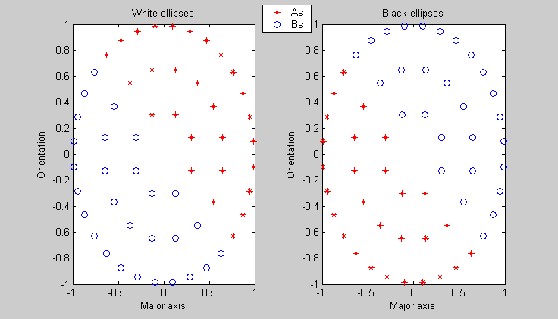
II II 4 condition will have following structure:
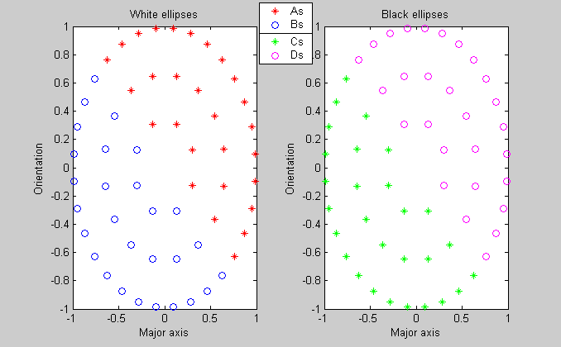

Trial design
CD type:
(resp terminated) cat stimulus
response
750ms feedback ('correct' in green, 'wrong' in red)
1500ms ITI

